Observation of Coherent Forward Scattering in a disordered quantum system

Clément Hainaut, Isam Manai, Jean-François Clément, Jean Claude Garreau, Pascal Szriftgiser, Gabriel Lemarié, Nicolas Cherroret, Dominique Delande, and Radu Chicireanu

Anderson localization is the absence of diffusion in certain disordered media. The transport and localization properties of disordered quantum systems are greatly affected by symmetries. Here, we present a novel technique [1,2] which allows the realization an artificial gauge field in a synthetic (temporal) dimension of a disordered, periodically driven (Floquet) quantum system. Our technique is used experimentally to control the Time-Reversal Symmetry properties of the Kicked Rotor – a paradigmatic model of classical and quantum chaos.

Using this system, we were recently able to provide the first observation and characterization of a direct ‘microscopic’ interference smoking gun of the Anderson Localization, the so-called “Coherent Forward Scattering” (CFS) phenomenon – thus confirming its very recent theoretical prediction [3]. This result is complemented by an accurate measurement of the universal scaling function β(g) [4] in two different universality classes. The Coherent Forward Scattering, in conjunction with its weak-localization counterpart, the “Coherent Backscattering” (CBS) [2], can be extremely valuable tools for future probing novel phenomena, emerging from the interplay of many-body effects or symmetry properties with the Anderson physics.

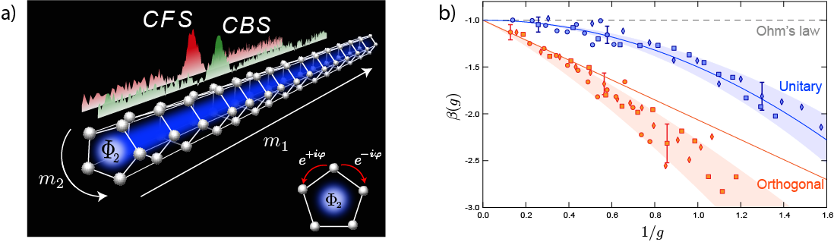

**Fig. 1** (a) Experimental observation of both CFS and CBS interference peaks, using the time-reversal properties of the Phase-Shifted Quantum Kicked Rotor (see [1] for details). (b) Measurement of the universal scaling function β(g) for two universality classes (Orthogonal and Unitary), with different Time-Reversal properties.

**References:**

[1] Hainaut, C. et al., Controlling symmetry and localization with an artificial gauge field in a disordered quantum system, Nat. Commun. **9**, 1382 (2018)

[2] Hainaut, C. et al., Return to the Origin as a Probe of Atomic Phase Coherence, Phys. Rev. Lett. **118**, 184101 (2017)

[3] Karpiuk, T. et al. Coherent forward scattering peak induced by Anderson localization, Phys. Rev. Lett. **109**, 190601 (2012)

[4] Abrahams, E., Anderson, P. W., Licciardello, D. C. & Ramakrishnan, T. V. Scaling theory of localization: absence of quantum diffusion in two dimensions, Phys. Rev. Lett. **42**, 673–676 (1979)